Laboratory 2: Flow Measuring Instrumentation
Laboratory
2

2.1 Introduction
Flow measurement is basic in any sampling scheme. Flow measuring instruments are classified as primary, intermediate, or secondary standards, depending on their accuracy and physical characteristics. In this laboratory exercise, you will use each of the three types of flow measuring instruments. From these exercises you will be able to use these flow measuring instruments and be better prepared to select the proper flow measuring instrument when sampling for atmospheric pollutants.
This laboratory session will consist of four experiments:

Experiment 1: The calibration of a wet test meter using the water displacement technique and the determination of the meter correction factor.
Experiment 2: The calibration of a mass flowmeter (or mass flow controller) using a bubble flow meter.
Experiment 3: The calibration of a rotameter at reduced pressure using a calibrated mass flowmeter. This experiment is designed to show the need to calibrate a rotameter under the conditions in which it is to be used.
Experiment 4: The limiting orifice experiment consists of three parts. Part 1 is the experimental determination of vacuum needed to obtain a constant volumetric flow rate. Part 2 is designed to show that, while this is a constant rate meter, an upstream pressure drop will affect the mass flow rate and, therefore, the orifice has to be calibrated in the system. Part 3 demonstrates that orifices have a directional difference and, therefore, these devices have to be calibrated in the same direction in which they are used. This laboratory procedure also makes use of a bubble flow meter as the calibration device.

Objectives
At the conclusion of this laboratory session, you will be able to:
- calibrate a wet test meter using a water displacement technique;
- calibrate a mass flowmeter (or mass flow controller);
- calibrate a rotameter in a bubbler train using a mass flowmeter (you will be able to describe the effects that variation in upstream pressure will produce on flow measurements); and
- describe how various factors affect orifice flow. These factors include:
  - vacuum,
  - effects of upstream resistance, and
  - effects of directional placement of a common orifice.

2.2 Experiment 1: Calibration of a Wet Test Meter

Introduction
Wet test meters are used as a laboratory standard. However, the time required for the equilibration of water temperature and dissolved gases in the water, and the meter’s bulk and weight, are disadvantages in using the wet test meter in the field. Wet test meters are very accurate, yet are classified as an intermediate standard because they cannot be calibrated by physical dimensional measurement. Therefore, wet test meters must be calibrated against a primary standard. An easy-to-use, inexpensive method to calibrate the wet test meter is the displacement bottle technique. A Class A volumetric flask is used to measure the displaced water and is considered the primary standard.

Calibration Equipment and Procedure

Equipment
To calibrate a 1-liter per revolution wet test meter, you need:
- a Class A, 2-liter volumetric flask;
- a 4-liter aspirator bottle (minimum size);
- a 2-hole rubber stopper, to fit into the top of the aspirator bottle;
- a piece of glass (or plastic) tubing, about three inches long, to fit the rubber stopper;
- a needle valve;
- rubber tubing: one piece of vacuum tubing two feet long, one end of which will be attached to the wet test meter, the other end to a needle valve; one piece of vacuum tubing long enough to reach from the needle valve to a vacuum source; two pieces of gum rubber tubing about two feet long;
- one tubing pinch clamp;
- a vacuum source;
- an impinger saturator;
- a manometer capable of measuring six inches of water pressure drop; and
- a thermometer.

Procedure
Understand the procedure thoroughly before proceeding. Be sure to read all footnotes.

- Assemble the aspirator bottle.
  - Attach one end of a piece of gum rubber tubing to the drain of the aspirator bottle (Lab 2, Figure 1a) and close off the other end of the tubing with a pinch clamp (Lab 2, Figure 1b).
  - Insert the 3-inch piece of glass or plastic tubing and a thermometer into the rubber stopper (Lab 2, Figure 1c). Set aside for use in step 12.
- Fill the aspirator bottle with water and allow the water to equilibrate to room temperature.
- Level the wet test meter. Adjust the meter until the bubble is exactly centered in the level (Lab 2, Figure 2a).
- Fill the wet test meter through its funnel with distilled water until the water just covers the pointer (Lab 2, Figure 2b).
- Attach one end of the 2-ft length of vacuum tubing to the wet test meter outlet. (The outlet and inlet will generally be identified on the meter.) Attach tubing of the necessary length to the vacuum source and affix the other end to the needle valve. The tubing should fit tightly over all fittings.
- With the needle valve closed, turn on the vacuum source.
- Open the needle valve to obtain a flow rate of 5 to 10 liters per minute of air. Allow the air to flow through the wet test meter for one hour. The purpose of this step is to saturate the water with air to prevent any of the measured air from becoming dissolved and lost during the calibration run.

IF YOU HAVE NOT READ THROUGH THE COMPLETE PROCEDURE, INCLUDING THE FOOTNOTES, DO SO NOW BEFORE CONTINUING.

- Cut off the vacuum source.
- Disconnect the needle valve and vacuum tubing so that both the inlet and outlet of the wet test meter are at atmospheric pressure.
- Check the wet test meter level and adjust if necessary.
- If necessary, draw off water through the small petcock (Lab 2, Figure 2) or add water as in step 4, adjusting the water level so the center of the concave meniscus seen in the sight glass (Lab 2, Figure 2b) just touches the tip of the pointer.
- Attach the gum rubber tubing to the glass or plastic piping which was inserted into the rubber stopper in step 1 (Lab 2, Figure 3a). Attach the other end to the meter outlet. Half-fill the impinger saturator with water and assemble the equipment as shown in Lab 2, Figure 3. Make certain that the rubber stopper is tight and there are no leaks in the wet test meter by checking the tightness of all fittings.
- Open the pinch clamp (Lab 2, Figure 3b) and allow the aspirator bottle drain hose to fill with water. Record the volume per revolution of the wet test meter (liters).
- Read the initial volume (V_{i}) from the wet test meter dial (Lab 2, Figure 3) and record on the wet test meter calibration data sheet.
- Place a clean, dry 2-liter volumetric flask (Class A) under the siphon tube, open the pinch clamp, and fill the volumetric flask to the 2-liter mark.
- While the water is flowing, record the saturator’s manometer reading (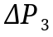) and the wet test meter’s manometer reading (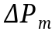). Record the following additional data:
  - meter water temperature, °C,
  - aspirator bottle temperature, °C, and
  - barometric pressure, mm Hg.
- At the point at which the volumetric flask reaches its calibrated capacity, stop the flow of water by quickly closing the pinch clamp, read the final volume (V_{f}) from the wet test meter dial, and record this value on the calibration data sheet. Pour the water back into the aspirator bottle.
- Repeat steps 14 through 17 twice.
- Calculate and record the corrected volume (V_{c}) using the following equation for each test:
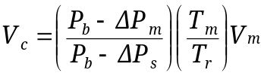
Where: P_{b} = barometric pressure, mm Hg
= wet test meter manometer reading, mm Hg
T_{r} = temperature of aspirator bottle, K (K = °C + 273)
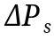 = saturator manometer reading, mm Hg
T_{m} = temperature at wet test meter, K (K = °C + 273)
V_{m} = volume measured by wet test meter,

An example of this calculation is presented below:

Barometric pressure, P_{b} = 742.2 mm Hg
Aspirator bottle temperature, T_{r} = 23.0°C + 273 = 296.0 K
Saturator manometer reading = 30.0 mm H₂O
Meter temperature, T_{m} = 22.5°C + 273 = 295.5 K
Meter manometer reading = 35.0 mm H₂O
V_{m} = 2.000

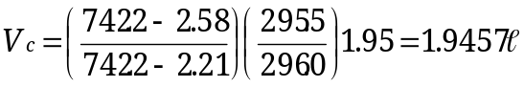

- Calculate and record the average corrected volume at meter conditions by:
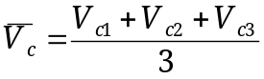.
- Calculate and record the error using the following equation:
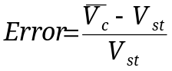

Where: V_{st} = the volume of the standard flask.

An example computation is presented below:

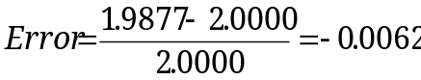

Determining the Correction Factor
The wet test meter error can be used to determine the correction factor (C.F.), as shown in the following equation:
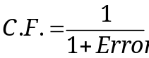

Using the Correction Factor
When using the wet test meter, the actual air volume can be determined by the equation:
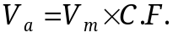

Where: V_{a} = volume of air that passed through the wet test meter
V_{m} = volume of air indicated by the wet test meter dials
C.F. = correction factor

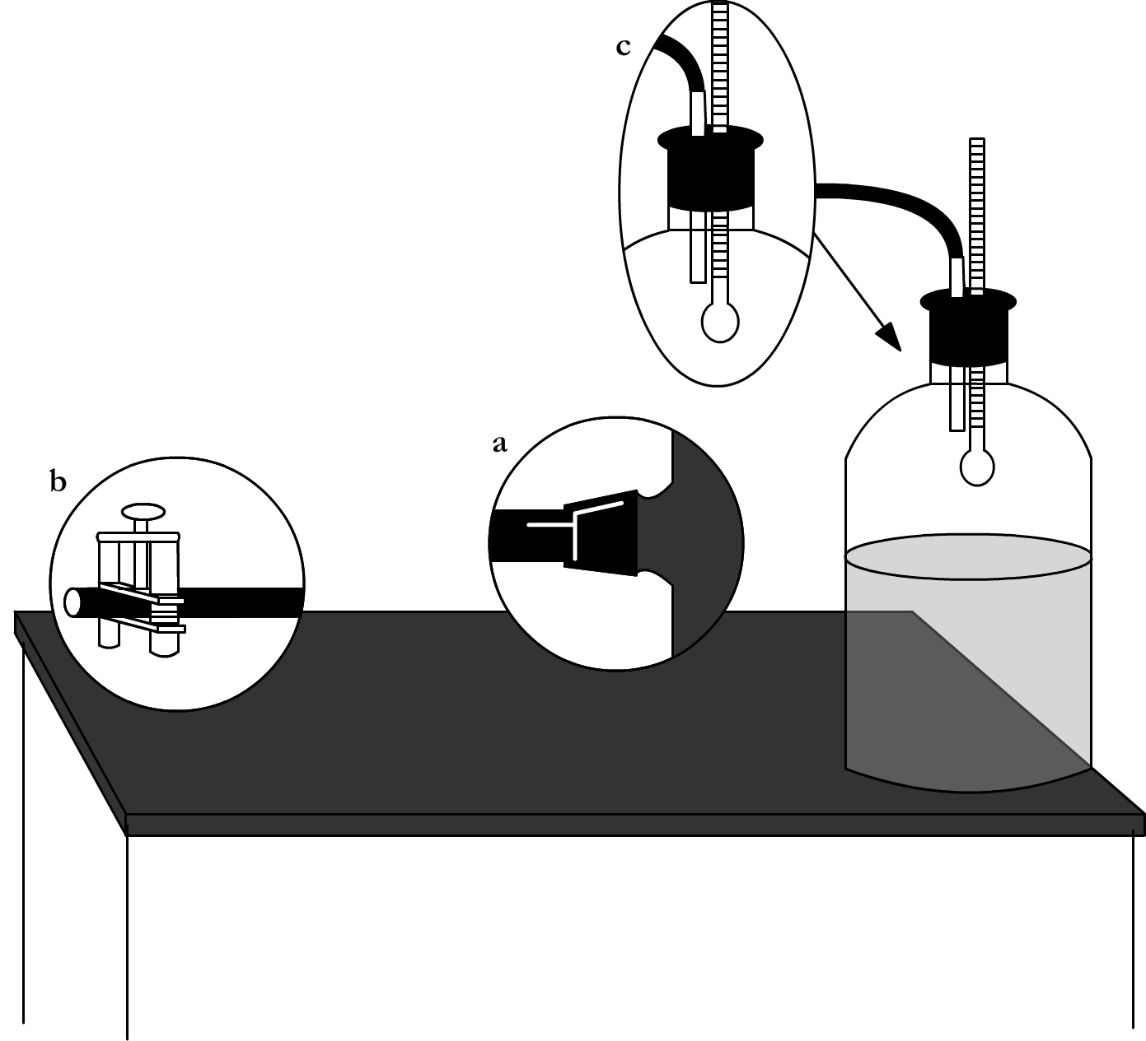
Lab 2, Figure 1. Aspirator bottle.
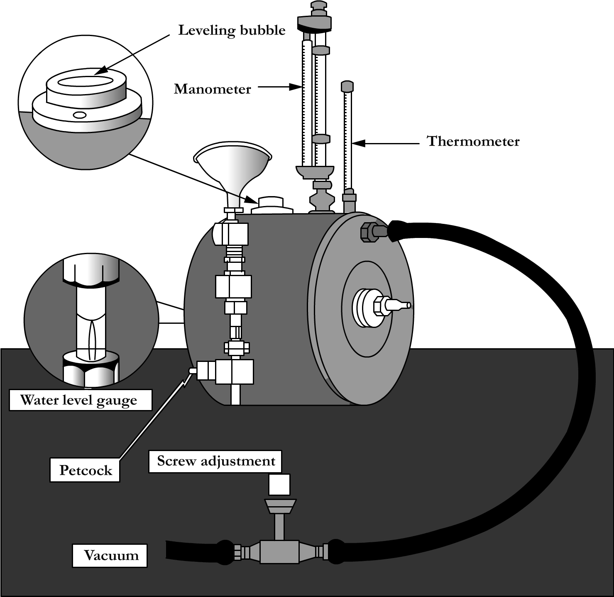
Lab 2, Figure 2. Wet test meter.
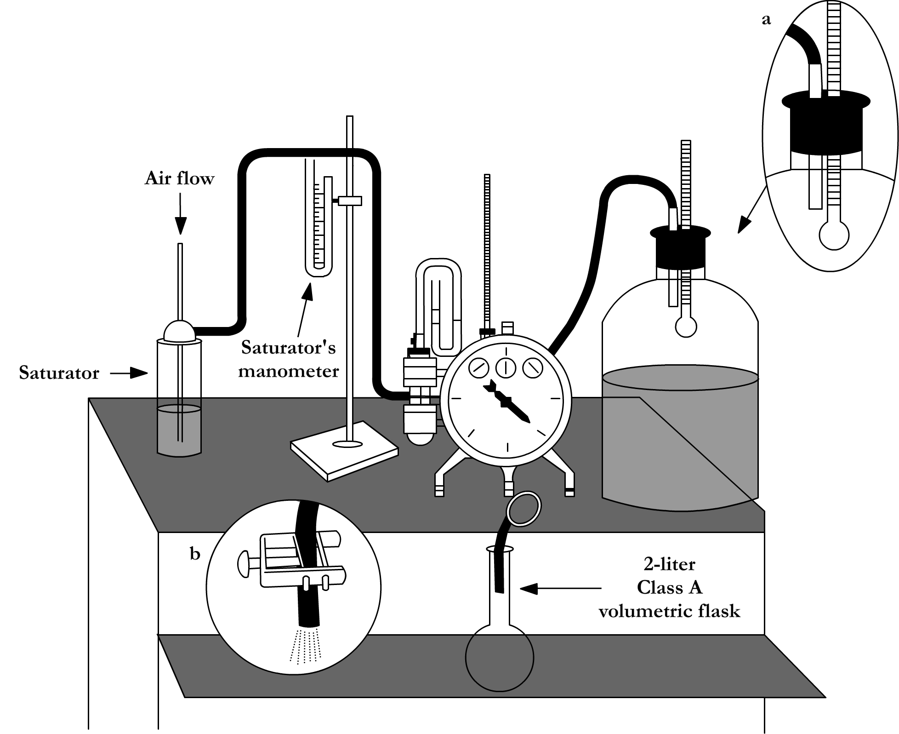
Lab 2, Figure 3. Calibration of the wet test meter using an aspirator bottle and Class A volumetric flask.
Lab 2, Table 1. Example Wet Test Meter Calibration Data Sheet.

Wet test meter serial no. _________123-A B________ Name _________SMS_________
Wet test meter 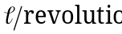 ________2 L__________ Date ________3/21/07________
Test flask volume, V_{st} _________2.000 L_________

Test number | Barometric pressure P_{b}  (mm Hg) | Aspirator bottle data |  | Saturator  data |  |  | Wet test meter data |  |  |  |  |  |  |  | Corrected  volume  V_{c}  (L) | Error | Correction Factor  (C.F.)
Test number | Barometric pressure P_{b}  (mm Hg) | Temperature T_{r} |  | Manometer reading, |  |  | Temperature  T_{m} |  | Manometer reading, |  |  | Meter reading |  |  | Corrected  volume  V_{c}  (L) | Error | Correction Factor  (C.F.)
Test number | Barometric pressure P_{b}  (mm Hg) | (°C) | (K) | (mm H₂O) | (mm Hg) |  | (°C) | (K) | (mm H₂O) |  | (mm Hg) | Final, V_{f}  (L) | Initial, V_{f}  (L) | V_{m}  (L) | Corrected  volume  V_{c}  (L) | Error | Correction Factor  (C.F.)
1 | 742.2 | 23.0 | 296.0 | 30.0 |  | 2.21 | 22.5 | 295.5 | 35.0 | 2.58 |  | 2.020 | 0.005 | 2.015 | 2.0106 | - | -
2 | 740.8 | 23.5 | 296.3 | 29.0 |  | 2.14 | 23.0 | 296.0 | 36.0 | 5399 |  | 2.041 | 0.015 | 2.026 | 2.0215 | - | -
3 | 735.3 | 22.5 | 295.5 | 31.0 |  | 2.29 | 22.0 | 295.0 | 35.5 | 2.62 |  | 2.056 | 0.021 | 2.035 | 2.0305 | - | -
Average | - | - | - | - |  | - | - | - | - | - |  | - | - | - | 2.0209 | -0.01045 | 0.9896

Calculations:
T_{r} = 23.0 °C + 273 = 296.0 K 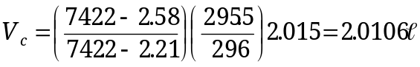
= 30.0 mm H₂O 0.0738 = 2.21 mm Hg 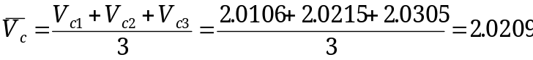
T_{m} = 22.5 °C + 273 = 295.5 K
= 35.0 mm H₂O 0.0738 = 2.58 mm Hg
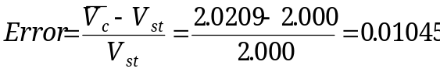
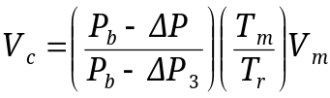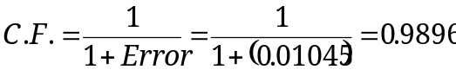

Note: If air is pushed through calibration system, and are to be added to 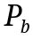.

Laboratory 2, Experiment 1: Wet Test Meter Calibration Data Sheet

Wet test meter serial no. ________________________ Name _______________________
Wet test meter 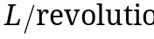_____________________ Date _______________________
Test flask volume, V_{st} ________________________

Test number | Barometric pressure P_{b}  (mm Hg) | Aspirator bottle data |  |  | Saturator  data |  |  | Wet test meter data |  |  |  |  |  |  |  | Corrected  volume  V_{c}  (L) | Error | Correction Factor  (C.F.)
Test number | Barometric pressure P_{b}  (mm Hg) | Temperature T_{r} |  |  | Manometer reading, |  |  | Temperature  T_{m} |  | Manometer reading, |  |  | Meter reading |  |  | Corrected  volume  V_{c}  (L) | Error | Correction Factor  (C.F.)
Test number | Barometric pressure P_{b}  (mm Hg) | (°C) |  | (K) | (mm H₂O) | (mm Hg) |  | (°C) | (K) | (mm H₂O) |  | (mm Hg) | Final, V_{f}  (L) | Initial, V_{f}  (L) | V_{m}  (L) | Corrected  volume  V_{c}  (L) | Error | Correction Factor  (C.F.)
1
2
3
Average

Calculations:

T_{r} = __________ °C + 273 = __________ K 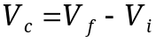
= __________ mm H₂O 0.0738 = __________ mm Hg 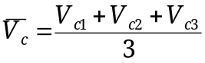
T_{m} = __________ °C + 273 = __________ K
= __________ mm H₂O 0.0738 = __________ mm Hg
__________L 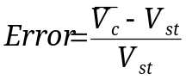
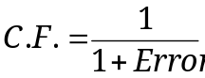
Note: If air is pushed through calibration system,
and are to be added to .
Page 1 of Lab Report

Laboratory 2, Experiment 1: Wet Test Meter Calibration Data Sheet

Wet test meter serial no. ________________________ Name _______________________
Wet test meter, _____________________ Date _______________________
Test flask volume, V_{st} ________________________

Test number | Barometric pressure P_{b}  (mm Hg) | Aspirator bottle data |  |  | Saturator  data |  |  | Wet test meter data |  |  |  |  |  |  |  | Corrected  volume  V_{c}  (L) | Error | Correction Factor  (C.F.)
Test number | Barometric pressure P_{b}  (mm Hg) | Temperature T_{r} |  |  | Manometer reading, |  |  | Temperature  T_{m} |  | Manometer reading, |  |  | Meter reading |  |  | Corrected  volume  V_{c}  (L) | Error | Correction Factor  (C.F.)
Test number | Barometric pressure P_{b}  (mm Hg) | (°C) |  | (K) | (mm H₂O) | (mm Hg) |  | (°C) | (K) | (mm H₂O) |  | (mm Hg) | Final, V_{f}  (L) | Initial, V_{f}  (L) | V_{m}  (L) | Corrected  volume  V_{c}  (L) | Error | Correction Factor  (C.F.)
1
2
3
Average

Calculations:

T_{r} = __________ °C + 273 = __________ K
= __________ mm H₂O 0.0738 = __________ mm Hg 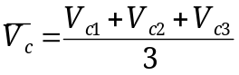
T_{m} = __________ °C + 273 = __________ K
= __________ mm H₂O 0.0738 = __________ mm Hg
__________L
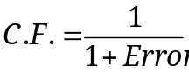
Note: If air is pushed through calibration system,
and are to be added to .
Page 1 of Lab Report

2.3 Experiment 2: Calibration of a Mass Flow Meter

Introduction
Mass flow meters (MFM) operate on the principle that when a gas passes over a heated surface, heat is transferred from the surface to the gas. The amount of electric current required to keep the surface at a constant temperature is a measure of the velocity of the gas. Since the amount of heat transferred depends only on the mass and velocity of the gas, these meters measure the true mass flow and have the advantage of measuring flow races without requiring corrections for changes of temperature and barometric pressure. Flow values from these meters are usually given in standard cubic centimeters per minute, which is the volume occupied by a given mass of a gas at standard temperature and pressure as specified by the manufacturer. Since mass flowmeters are not volume displacement devices, they require periodic calibration against a primary flow measuring device, such as a bubble flow meter.
Mass flow controllers (MFC), like MFM, measure flow rate; however, MFC have the added capability of controlling flow at a prescribed rate. This feature makes MFC particularly well-suited as flow controlling and measuring devices in modern dynamic gas calibrators. It is typical to employ two MFC in a dynamic gas calibrator; one to measure and meter the dilutent gas (i.e., zero air), and the other to measure and meter the calibration gas (e.g., NO, CO, etc.).

Calibration Procedure
Mass flow meters can be calibrated by employing a calibrated automated bubble meter as a calibration standard as follows:

- With the mass flowmeter off, adjust the meter to zero with the pointer needle adjustment screw located below the meter face, if so equipped.
- Turn on the meter and allow it to warm up (typically 30 minutes).
- After the warm-up period, adjust the electronic zero as follows:
  - Plug up the inlet and outlet of the transducer.
  - Adjust the electronic zero adjustment screw until the meter reads zero.
  - Unplug the transducer and connect it to the test apparatus as illustrated in Lab 2, Figure 4.
- Turn on the vacuum pump and adjust the flow rate, with the needle valve, to approximately 80% of full scale of the mass flow meter.
- Allow the flow meter reading to stabilize.
- Read and record the flow rate as measured by the bubble flow meter as Q_{m}.
- Record laboratory temperature, T_{m}, in K and barometric pressure, P_{b}, in mm Hg.
- Calculate Q_{std} for the bubble meter from P_{b}, T_{m}, Q_{m}, and the vapor pressure (VP) and record on the calibration data sheet.

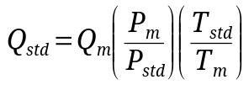

- Plot Q_{std} versus mass flow meter readings on arithmetic graph paper.
- Repeat steps 6 through 13 for approximately 60%, 40%, and 20% of the range of the mass flowmeter.
- Construct a best-fit curve for the points generated and use this relationship for future work employing the mass flow meter.

A partially completed example data sheet is found in Lab 2, Table 2.

Note: When calibrating a mass flow controller (MFC) which is integrated into a dynamic gas calibrator unit, it is best to refer to the manufacturer’s instructions. As an example, the basic procedure for the calibration of a Thermo Environmental Instruments Dynamic Calibrator (Model 146C) is as follows.

Calibration of a Thermo Environmental Instruments Dynamic Calibrator (Model 146C)
In order to calibrate the mass flow meter section of the zero or gas mass flow controller, a NIST traceable flow meter is required. The term calibration means determining the actual flow versus the flow setting for seven equally spaced flows along the range of the device. The Model 146C then corrects the output according to an internal algorithm.
The long-term stability of the flow controllers is quite good. As shipped from the factory, the target flow and actual flow from 20 to 100 percent of full scale agree to within 2 percent of reading or 1 percent of full-scale, whichever is less. Calibration may be done with a properly calibrated flow meter. For the most accurate calibration procedure, use a volumetric NIST traceable calibrator with the following step-by-step calibration procedure.

- Connect a source of clean, dry air to the inlet of the mass flow controller.
- Measure barometric pressure and room temperature.
- Connect a suitable flow meter to the mass flow controller outlet.
- Set Model 146C to Gas Drive or Zero Air Flow Calibration as described in Chapter 3, “Operation,” in the Operators Manual for the Model 146C.
- Set flow controller to 95 percent of full scale, then wait until flow meter reading stabilizes.
- Enter the flow meter reading using the flow input screen.
- Repeat steps 5 and 6 for the remaining flow settings.
- If difficulty is encountered due to a malfunction of the flow controller, contact Thermo Environmental Instruments.
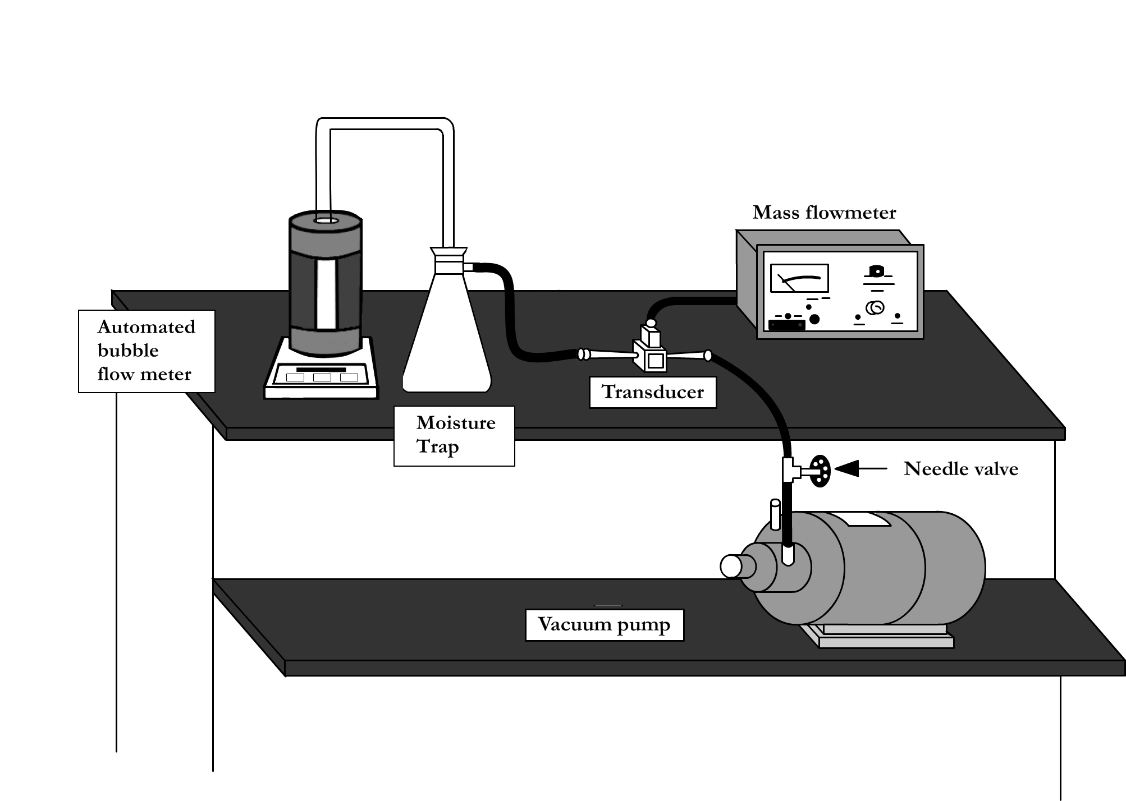
Lab 2, Figure 4. Mass flow meter calibration setup.
Lab 2, Table 2. Example Mass Flowmeter Calibration Data Sheet
Name ___Joe Smith_____
Date _____5/18/08______
Group no. ____2_________

Laboratory Temperature, T_{m} ____22.0___°C __295.0 _ K
Vapor Pressure (see Saturation Vapor Pressure table in
Limiting Orifice Laboratory Exercise), VP 19.827 mm Hg
Mass flowmeter no. _________1573________________
Mass flowmeter range setting _1000 cc/min (1.0 l/min)__
Barometric pressure, P_{b} ____750.00___ mm Hg
Transducer no. ____873_______

Approximate mass flowmeter  (% full scale) | Bubble Meter  Q_{m}  (L) | Bubble Meter  Q_{std} | Mass flow reading  (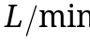)
80 | 0.820 | 0.796 | 0.800
60
40
20

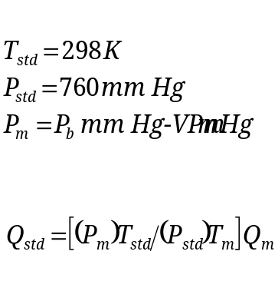
Example Calculations:

Calculations based on data in table above.
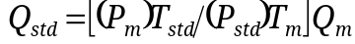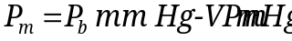

Laboratory 2, Experiment 2: Mass Flowmeter Calibration Data Sheet

Name ______________________
Date ______________________
Group no. ____________________

Laboratory Temperature, T_{m} _________°C _________ K
Vapor Pressure (see Saturation Vapor Pressure table in
Limiting Orifice Laboratory Exercise), VP 19.827 mm Hg
Mass flowmeter no. _________________________
Mass flowmeter range setting __________________
Barometric pressure, P_{b} _______________________
Transducer no. ____________________

Approximate mass flowmeter  (% full scale) | Bubble Meter  Q_{m}  (L) | Bubble Meter  Q_{std} | Mass flow reading  ()
80
60
40
20

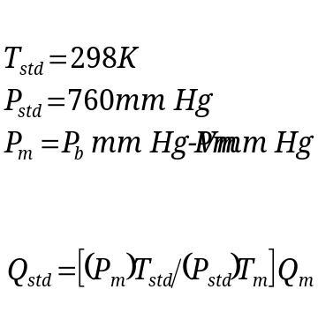

Page 2 of Lab Report

Laboratory 2, Experiment 2: Mass Flowmeter Calibration Data Sheet

Name ______________________
Date ______________________
Group no. ____________________

Laboratory Temperature, T_{m} _________°C _________ K
Vapor Pressure (see Saturation Vapor Pressure table in
Limiting Orifice Laboratory Exercise), VP 19.827 mm Hg
Mass flowmeter no. _________________________
Mass flowmeter range setting __________________
Barometric pressure, P_{b} _______________________
Transducer no. ____________________

Approximate mass flowmeter  (% full scale) | Bubble Meter  Q_{m}  (L) | Bubble Meter  Q_{std} | Mass flow reading  (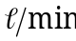)
80
60
40
20

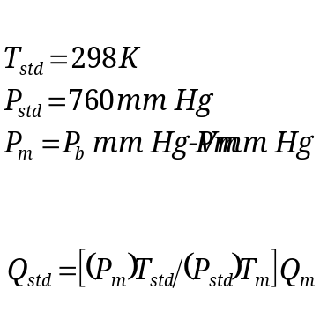

Page 2 of Lab Report

2.4 Experiment 3: Calibration of a Rotameter at Reduced Pressure

Introduction
Although rotameters remain in use as flow measuring devices, they have been replaced by mass flow meters and controllers to a large extent. Since they require no power to operate and are relatively rugged, they continue to be used in some sampling trains which are designed to manually collect samples. In addition, they are regularly used as “gross” indicators of gas flow. For example, they can provide an easy means of visually determining the presence of excess gas flow in a sampling manifold to reassure the operator the instrument under calibration is receiving sufficient calibration gas.
A rotameter is a conical tube with an internal float. Changes in the flow rate cause the float to move up and down the conical tube. The length of the conical tube has a scale which corresponds to a flow rate. In most cases, the scale is not assigned a corresponding flow rate until the device is calibrated. (See Variable Area Meters in Chapter 3 of the Student Manual.) Corrections can be made to the rotameter measurements; however, it is simpler and more accurate to calibrate a rotameter at the conditions at which it will be used.
In this experiment, you will calibrate a rotameter with a mass flow meter (or mass flow controller) at two different upstream pressures.

Calibration Procedure
The setup is shown in Lab 2, Figure 5. Record room temperature and barometric pressure, P_{b}.
- Close valve B.
- Fully open valve A.
- Turn on pump.
- Adjust valve B until the rotameter reads approximately 80% full scale. Read the float at the point at which it is highest and widest. For example, if the float is a sphere, it should be read at its greatest diameter (the middle of the sphere).
- Record the rotameter setting, mass flow meter reading, and vacuum pressure reading, p_{g}, on the data sheet.
- Reduce the flow rate to approximately 60% full scale on the rotameter by adjusting valve B. It is not necessary to set the rotameter at a specific number.
- Adjust valve A so that the pressure reading is the same as in step 5. Repeat steps 6 and 7 for fine adjustment of the p_{g} reading. You may have to repeat steps 6 and 7 many times because of lags in your pressure drop. It is important to set the p_{g} value at exactly the same reading, but it is not necessary to set the rotameter reading. Just read the rotameter accurately.
- Repeat steps 6 and 7 for rotameter settings of approximately 40% and 20% of full scale. Note: You have just calibrated the rotameter at one upstream pressure condition. Next, you will change the upstream pressure of the rotameter and calibrate it again.
- Adjust valves A and B so that an 80% full scale rotameter reading is obtained at a new p_{g} value, which should be 2 to 3 times the p_{g} value used for the first curve. Repeat steps 5 through 8 to obtain a calibration curve at this new p_{g}. Since you are going to plot curves, it is not necessary to try and duplicate the rotameter readings obtained in the first part of the experiment.
- Convert your gauge pressure readings to absolute pressure by using
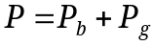. Remember, P_{g} is a vacuum in this case and has a negative sign.
- Correct all mass flowmeter readings to flow by using the mass flowmeter’s calibration curve as prepared in Laboratory 2, Experiment 2. If the calibration curve is not available, assume the mass flow meter output is accurate.
- Plot the two resulting curves on the same graph paper. Use the x-axis for flow () and y-axis for rotameter reading. Be sure to note the absolute upstream pressure (P) on each curve.

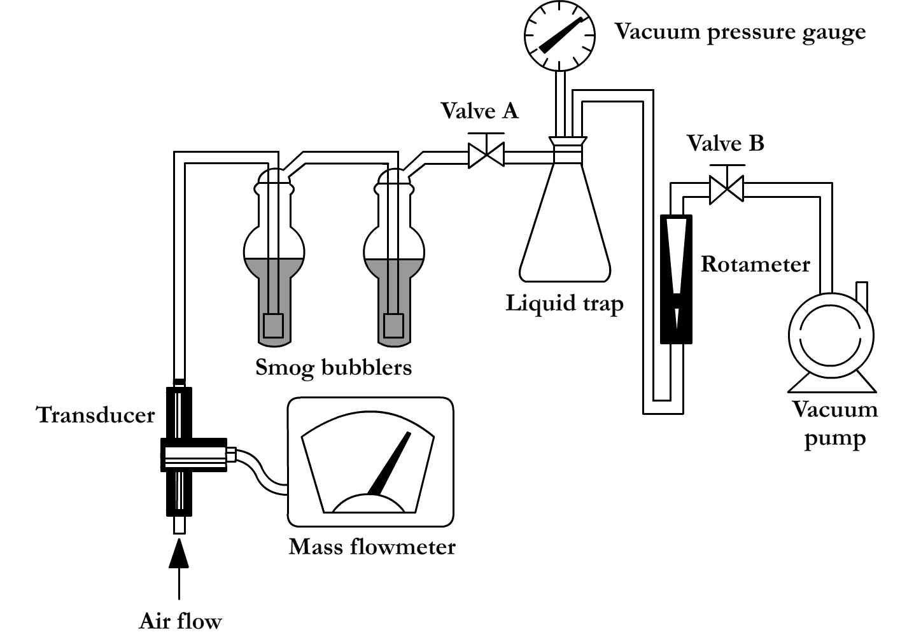
Lab 2, Figure 5. Calibration of a rotameter at reduced pressure.

Laboratory 2, Experiment 3: Rotameter Calibration Data Sheet

Room temperature ________________°C Name__________________
Mass flowmeter no. _________________ Date__________________
Barometric pressure, P_{b} ______________ Group no._______________
Transducer no. ____________________
Rotameter no. ____________________

Mass flowmeter reading | Flow as indicated by mass flow meter’s calibration curve  () | Rotameter reading | Upstream pressure or vacuum  P_{g} | Absolute upstream pressure  P | Pressure setting no.
 |  |  |  |  | 1
2

Reduced pressure

Page 3 of Lab Report

Laboratory 2, Experiment 3: Rotameter Calibration Data Sheet

Room temperature ________________°C Name__________________
Mass flowmeter no._________________ Date__________________
Barometric pressure, P_{b} ______________ Group no._______________
Transducer no. ___________________
Rotameter no. ____________________

Mass flowmeter reading | Flow as indicated by mass flow meter’s calibration curve  () | Rotameter reading | Upstream pressure or vacuum  P_{g} | Absolute upstream pressure  P | Pressure setting no.
 |  |  |  |  | 1
2

Reduced pressure

Page 3 of Lab Report

2.5 Experiment 4: Calibration of a Limiting Orifice and Investigation of Factors Affecting Flow

Introduction
Limiting orifices are commonly used to control flow rate. In this experiment, you will calibrate a limiting orifice with a soap bubble meter (or automated flow meter) to determine:
- at what vacuum pressure the pressure drop across the orifice causes it to become a limiting orifice,
- the effect of upstream pressure on flow rate, and
- the effect on flow rate of reversing the direction of flow through the orifice.
The description of a soap bubble meter (or automated flow meters) can be found in Chapter 3 of the Student Manual under the topic of volume meters.

Determination of Critical Vacuum – Part I
The setup is shown in Lab 2, Figure 6. Record room temperature, T, and barometric pressure, P_{b}.
- Make sure to orient the inlet side of the orifice so it is pointed toward vacuum gauge #1.
- Leave needle valve #1 completely open (to open, turn counterclockwise).
- Turn on the vacuum pump.
- Adjust needle valve #2 until about five inches of Hg vacuum are registered on vacuum gauge #2.
- Using the moving bubble meter (or automated flow meters), determine and record the time required for the specified volume to flow through the bubble meter (see Part I of data sheet for the specified volume).
- Repeat at other vacuum settings (see Part I of data sheet for other vacuum settings).
- Calculate and correct the flow rate for each vacuum setting as directed below.
- Plot flow rate on the y-axis and vacuum pressure on the x-axis. At what vacuum pressure does the flow become constant? What is this flow rate?
The use of the soap bubble meter for the calibration of flow rate devices requires correction for temperature, barometric pressure, and the vapor pressure of the soap bubble, which is considered to be that of the vapor pressure of water. The equation below is presented to assist the user of the soap bubble meter with these corrections.

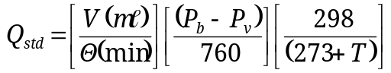
Where: Q_{std} = flow rate corrected to standard conditions
P_{b} = barometric pressure, mm Hg
P_{v} = vapor pressure of water, mm Hg (see Lab 2, Table 3)
T = temperature of gas, °C (room temperature)
V = volume measured by bubble meter
θ = time for measured volume to flow through bubble meter

Example: Assume temperature to be 20°C and barometric pressure to be 710 mm Hg.

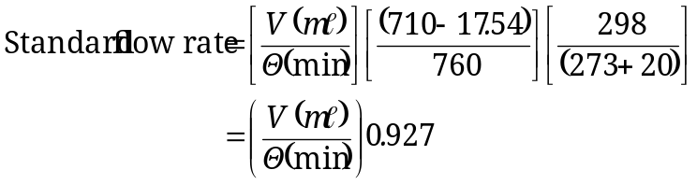

If an automated flow meter (e.g., Gilibrator™, Dry-Cal™) which provides an output reading as a flow rate (ml/min) is used in place of a simple bubble meter, then make the following substitute in the equation above:
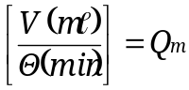

Where: Q_{m} = flow rate as measured by the automated flow meter

If an automated flow meter is used that does not utilize a liquid soap bubble (e.g., Dry-Cal ™) then, in addition to the substitution mentioned previously, also remove the term P_{v} from the original equation. The term P_{v} is removed since this type of flow meter does not introduce water vapor while measuring the volumetric flow rate.

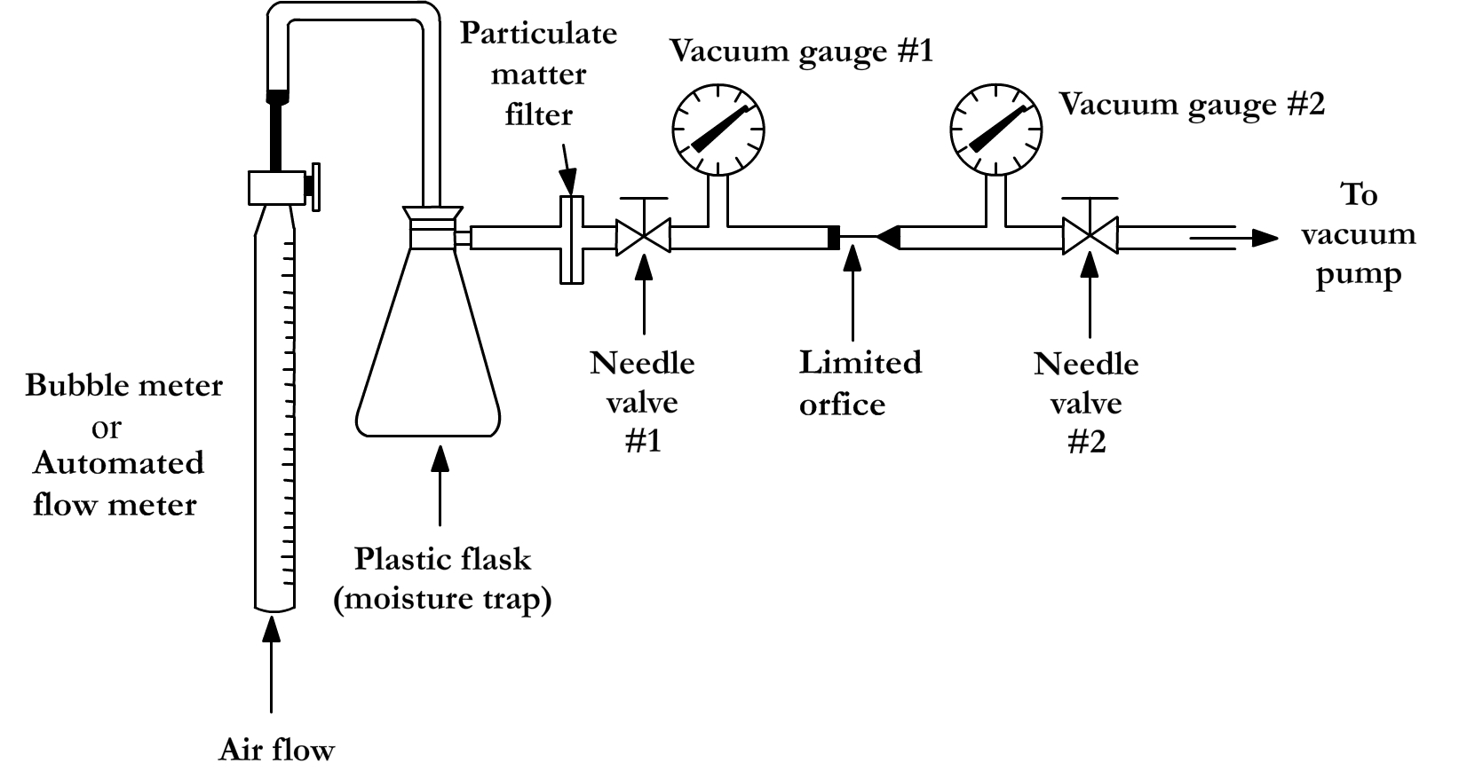
Lab 2, Figure 6. Calibration of a limiting orifice using a bubble meter.
Lab 2, Table 2. Saturation vapor pressure over water (°C, mm Hg).
Values for fractional degree between 50 and 89 were obtained by interpolation
Temp. °C | 0.0 | 0.2 | 0.4 | 0.6 | 0.8 | Temp. °C | 0.0 | 0.2 | 0.4 | 0.6 | 0.8
-15 | 1.436 | 1.414 | 1.390 | 1.368 | 1.345 | 42 | 61.50 | 62.14 | 62.80 | 63.46 | 64.12
-14 | 1.560 | 1.534 | 1.511 | 1.485 | 1.460 | 43 | 64.80 | 65.48 | 66.16 | 66.86 | 67.56
-13 | 1.691 | 1.665 | 1.637 | 1.611 | 1.585 | 44 | 68.26 | 68.97 | 69.69 | 70.41 | 71.14
-12 | 1.834 | 1.804 | 1.776 | 1.748 | 1.720
-11 | 1.987 | 1.955 | 1.924 | 1.893 | 1.863 | 45 | 71.88 | 72.62 | 73.36 | 74.12 | 74.88
 |  |  |  |  |  | 46 | 75.65 | 76.43 | 77.21 | 78.00 | 78.80
-10 | 2.149 | 2.116 | 2.084 | 2.050 | 2.018 | 47 | 79.60 | 80.41 | 81.23 | 82.05 | 82.87
-9 | 2.326 | 2.289 | 2.254 | 2.219 | 2.184 | 48 | 83.71 | 84.56 | 85.42 | 86.28 | 87.14
-8 | 2.514 | 2.475 | 2.437 | 2.399 | 2.362 | 49 | 88.02 | 88.90 | 89.79 | 90.69 | 91.59
-7 | 2.715 | 2.674 | 2.635 | 2.593 | 2.553
-6 | 2.931 | 2.887 | 2.843 | 2.800 | 2.757 | 50 | 92.51 | 93.5 | 94.4 | 95.3 | 96.3
 |  |  |  |  |  | 51 | 97.20 | 98.2 | 99.1 | 100.1 | 101.1
-5 | 3.163 | 3.115 | 3.069 | 3.022 | 2.976 | 52 | 102.09 | 103.1 | 104.1 | 105.1 | 106.2
-4 | 3.410 | 3.359 | 3.309 | 3.259 | 3.211 | 53 | 107.20 | 108.2 | 109.3 | 110.4 | 111.4
-3 | 3.673 | 3.620 | 3.567 | 3.514 | 3.461 | 54 | 112.51 | 113.6 | 114.7 | 115.8 | 116.9
-2 | 3.956 | 3.898 | 3.841 | 3.785 | 3.730
-1 | 4.258 | 4.196 | 4.135 | 4.075 | 4.016 | 55 | 118.04 | 119.1 | 120.3 | 121.5 | 122.6
 |  |  |  |  |  | 56 | 123.90 | 125.0 | 126.2 | 127.4 | 128.6
-0 | 4.579 | 4.513 | 4.448 | 4.385 | 4.320 | 57 | 129.82 | 131.0 | 132.3 | 133.5 | 134.7
 |  |  |  |  |  | 58 | 136.08 | 137.3 | 138.5 | 139.9 | 141.2
0 | 4.579 | 4.647 | 4.715 | 4.785 | 4.855 | 59 | 142.60 | 143.9 | 145.2 | 146.6 | 148.0
1 | 4.926 | 4.998 | 5.070 | 5.144 | 5.219
2 | 5.294 | 5.370 | 5.447 | 5.525 | 5.605 | 60 | 149.38 | 150.7 | 152.1 | 153.5 | 155.0
3 | 5.685 | 5.766 | 5.848 | 5.931 | 6.015 | 61 | 156.43 | 157.8 | 159.3 | 160.8 | 162.3
4 | 6.101 | 6.187 | 6.274 | 6.363 | 6.453 | 62 | 163.77 | 165.2 | 166.8 | 168.3 | 169.8
 |  |  |  |  |  | 63 | 171.38 | 172.9 | 174.5 | 176.1 | 177.7
5 | 6.543 | 6.635 | 6.728 | 6.822 | 6.917 | 64 | 179.31 | 180.9 | 182.5 | 184.2 | 185.8
6 | 7.013 | 7.111 | 7.209 | 7.309 | 7.411
7 | 7.513 | 7.617 | 7.722 | 7.828 | 7.936 | 65 | 187.54 | 189.2 | 190.9 | 192.6 | 194.3
8 | 8.045 | 8.155 | 8.267 | 8.380 | 8.484 | 66 | 196.09 | 197.8 | 199.5 | 201.3 | 203.1
9 | 8.609 | 8.727 | 8.845 | 8.965 | 9.086 | 67 | 204.96 | 206.8 | 208.6 | 210.5 | 212.3
 |  |  |  |  |  | 68 | 214.17 | 216.0 | 218.0 | 219.9 | 221.8
10 | 9.209 | 9.333 | 9.458 | 9.585 | 9.714 | 69 | 223.78 | 225.7 | 227.7 | 229.7 | 231.7
11 | 9.844 | 9.976 | 10.109 | 10.244 | 10.380
12 | 10.518 | 10.658 | 10.799 | 10.941 | 11.085 | 70 | 233.7 | 235.7 | 237.7 | 239.7 | 241.8
13 | 11.231 | 11.379 | 11.528 | 11.680 | 11.833 | 71 | 243.9 | 246.0 | 248.2 | 250.3 | 252.7
14 | 11.987 | 12.144 | 12.302 | 12.462 | 12.624 | 72 | 254.6 | 256.8 | 259.0 | 261.2 | 263.4
 |  |  |  |  |  | 73 | 265.7 | 268.0 | 270.2 | 272.6 | 274.8
15 | 12.788 | 12.953 | 13.121 | 13.290 | 13.461 | 74 | 277.2 | 279.4 | 281.8 | 284.2 | 286.6
16 | 13.634 | 13.809 | 13.987 | 14.166 | 14.347 | 75 | 289.1 | 291.5 | 294.0 | 296.4 | 298.8
17 | 14.530 | 14.715 | 14.903 | 15.092 | 15.284 | 76 | 301.4 | 303.8 | 306.4 | 308.9 | 311.4
18 | 15.477 | 15.673 | 15.871 | 16.071 | 16.272 | 77 | 314.1 | 316.6 | 319.2 | 322.0 | 324.6
19 | 16.477 | 16.685 | 16.894 | 17.105 | 17.319 | 78 | 327.3 | 330.0 | 332.8 | 335.6 | 338.2
 |  |  |  |  |  | 79 | 341.0 | 343.8 | 346.6 | 349.4 | 352.2
20 | 17.535 | 17.853 | 17.974 | 18.197 | 18.422
21 | 18.650 | 18.880 | 19.113 | 19.349 | 19.587 | 80 | 355.1 | 358.0 | 361.0 | 363.8 | 366.8
22 | 19.827 | 20.070 | 20.312 | 20.565 | 20.815 | 81 | 369.7 | 372.6 | 375.6 | 378.8 | 381.8
23 | 21.068 | 21.324 | 21.583 | 21.845 | 22.110 | 82 | 384.9 | 388.0 | 391.2 | 394.4 | 397.4
24 | 22.377 | 22.648 | 22.922 | 23.198 | 23.476 | 83 | 400.6 | 403.8 | 407.0 | 410.2 | 413.6
 |  |  |  |  |  | 84 | 416.8 | 420.2 | 423.6 | 426.8 | 430.2
25 | 23.756 | 24.039 | 24.326 | 24.617 | 24.912
26 | 25.209 | 25.509 | 25.812 | 26.117 | 26.426 | 85 | 433.6 | 437.0 | 440.4 | 444.0 | 447.5
27 | 26.739 | 27.055 | 27.374 | 27.696 | 28.021 | 86 | 450.9 | 454.4 | 458.0 | 461.6 | 465.2
28 | 28.349 | 28.680 | 29.015 | 29.354 | 29.697 | 87 | 468.7 | 472.4 | 476.0 | 479.8 | 483.4
29 | 30.043 | 30.392 | 30.745 | 31.102 | 31.461 | 88 | 487.1 | 491.0 | 494.7 | 498.5 | 502.2
 |  |  |  |  |  | 89 | 506.1 | 510.0 | 513.9 | 517.8 | 521.8
30 | 31.824 | 32.191 | 32.561 | 32.934 | 33.312
31 | 33.695 | 34.082 | 34.471 | 34.864 | 35.261 | 90 | 525.76 | 529.77 | 533.90 | 537.86 | 541.95
32 | 35.663 | 36.068 | 36.477 | 36.891 | 37.308 | 91 | 546.05 | 550.18 | 554.35 | 558.53 | 562.75
33 | 37.729 | 38.155 | 38.584 | 39.018 | 39.457 | 92 | 566.99 | 571.26 | 575.55 | 579.87 | 584.22
34 | 39.898 | 40.344 | 40.796 | 41.251 | 41.710 | 93 | 588.60 | 593.00 | 597.43 | 601.89 | 606.38
 |  |  |  |  |  | 94 | 610.90 | 615.44 | 620.01 | 624.61 | 629.24
35 | 42.175 | 42.644 | 43.117 | 43.595 | 44.078 | 95 | 633.90 | 638.59 | 643.30 | 648.05 | 652.82
36 | 44.563 | 45.054 | 45.549 | 46.050 | 46.556 | 96 | 657.62 | 662.45 | 667.31 | 672.20 | 677.12
37 | 47.067 | 47.582 | 48.102 | 48.627 | 49.157 | 97 | 682.07 | 687.04 | 692.05 | 697.10 | 702.17
38 | 49.692 | 50.231 | 50.774 | 51.323 | 57.879 | 98 | 707.27 | 712.40 | 717.56 | 722.75 | 727.98
39 | 52.442 | 53.009 | 53.580 | 54.156 | 54.737 | 99 | 733.24 | 738.53 | 743.85 | 749.20 | 754.58
40 | 55.324 | 55.91 | 56.51 | 57.11 | 57.72 | 100 | 760.00 | 765.45 | 770.93 | 776.55 | 782.00
41 | 58.34 | 58.96 | 59.58 | 60.22 | 60.86 | 101 | 787.57 | 793.18 | 798.82 | 804.50 | 810.21

Effect of Upstream Resistance – Part II

- Adjust needle valve #2 to maintain 25 in. Hg vacuum.
- Place resistance in front of the orifice by adjusting needle valve #1 until vacuum gauge #1 shows 10 in. Hg vacuum.
- Determine the flow rate under these conditions using the bubble flowmeter or automated flow meter. Determine and record the time required to pass 400 mL through the bubble flowmeter. Calculate the flow as in Part I and record on the data sheet, Part II.
- Calculate the percentage of change in flow rate using the following formula:

The difference between this flow rate and that determined in Part I demonstrates the need to calibrate the orifice in the system in which it is going to be used.

Effect of Reversing Orifice – Part III

- Shut off the vacuum pump.
- Reverse the orifice. The orifice should be oriented with the inlet side of the orifice pointed toward vacuum gauge #2.
- Turn on the vacuum pump.
- Completely open needle valve #1.
- Obtain a vacuum of 25 in. Hg on gauge #2 and determine the flow rate as in Part I.
- Record the information on the data sheet, Part III.
- Calculate the % change using the following formula:

This demonstrates the error that would result if you calibrated the orifice in one direction and used it in the other direction.

Laboratory 2, Experiment 4: Limiting Orifice Calibration Data Sheet

P_{b} _______________________ mm Hg Name__________________
T ___________________________ °C Date__________________
Needle gauge____________________ Group no._______________

Part I Data
Vacuum  (in. Hg) | Volume  (mL) | Time  (min) | Flow rate, Q_{std}  (mL/min)
5 | 200
10 | 200
13 | 400
15 | 400
17 | 400
19 | 400
21 | 400
23 | 400
25 | 400
Maximum  vacuum | 400

Part II Data
Condition | Vacuum gauge #1 | Vacuum gauge #2 | Volume  (mL) | Time  (min) | Flow rate, Q_{std}  (mL/min)
Data from  Part I | 0 | 25 | 400
Resistance  in system | 10 | 25 | 400

% Change = _________

Part III Data
Condition | Vacuum (in. Hg) | Volume  (mL) | Time  (min) | Flow rate, Q_{std}  (mL/min)
Data from  Part I | 25 | 400
Orifice  reversed | 25 | 400

% Change = _________

Page 4 of Lab Report

Laboratory 2, Experiment 4: Limiting Orifice Calibration Data Sheet

P_{b} _______________________ mm Hg Name __________________
T ___________________________ °C Date __________________
Needle gauge____________________ Group no._______________

Part I Data
Vacuum  (in. Hg) | Volume  (mL) | Time  (min) | Flow rate, Q_{std}  (mL/min)
5 | 200
10 | 200
13 | 400
15 | 400
17 | 400
19 | 400
21 | 400
23 | 400
25 | 400
Maximum  vacuum | 400

Part II Data
Condition | Vacuum gauge #1 | Vacuum gauge #2 | Volume  (mL) | Time  (min) | Flow rate, Q_{std}  (mL/min)
Data from  Part I | 0 | 25 | 400
Resistance  in system | 10 | 25 | 400

% Change = _________

Part III Data
Condition | Vacuum (in. Hg) | Volume  (mL) | Time  (min) | Flow rate, Q_{std}  (mL/min)
Data from  Part I | 25 | 400
Orifice  reversed | 25 | 400

% Change = _________

Page 4 of Lab Report

The diameter of the tubing used should fit tightly over the wet test meter and needle valve fittings, aspirator bottle tabulation, and the tubing for the rubber stopper.
The wet test meter should be leveled and adjusted, if necessary, each time the meter is moved. Usually two or more of the wet test meter feet are screw adjustments. The meter can be leveled by turning these.
Whenever the water is checked or adjusted, the inlet and outlet should be open to the atmosphere, i.e., at atmospheric pressure, and the meter should be level.
The mouth of the 2-liter flask must be below the final water level of the aspirator bottle. The lower the flask and hose combination, the faster the water flow.
See Lab 1 for the proper reading of a manometer.
Error, as determined above, may be positive or negative, and the sign should be carried in the determination of the correction factor (C.F.).
Refer to the manufacturer’s instructions for specific procedures and flow rate capacities.
If a flow meter that utilizes a soap bubble is used, a correction for the addition of moisture to the gas stream must be performed as shown. The vapor pressure (VP) can be determined by referring to the Saturation Vapor Pressure table in the limiting orifice laboratory exercise (page 77). If a flow device such as a Dry-Cal™ is used the P_{m} is simply the barometric pressure.
If a flow meter that utilizes a soap bubble is used, a correction for the addition of moisture to the gas stream must be performed as shown. The vapor pressure (VP) can be determined by referring to the Saturation Vapor Pressure table in the limiting orifice laboratory exercise (page 77). If a flow device such as a Dry-Cal™ is used the P_{m} is simply the barometric pressure.
If a flow meter that utilizes a soap bubble is used, a correction for the addition of moisture to the gas stream must be performed as shown. The vapor pressure (VP) can be determined by referring to the Saturation Vapor Pressure table in the limiting orifice laboratory exercise (page 77). If a flow device such as a Dry-Cal™ is used the P_{m} is simply the barometric pressure.
Book of Chemistry and Physics, 45th edition. 1965. Chemical Rubber Publishing Company.

